**Ideation Phase**

**Define the Problem Statements**

|  |  |
| --- | --- |
| Date | 30 June 2025 |
| Team ID | LTVIP2025TMID30156 |
| Project Name | Educational Organisation Using ServiceNow |
| Maximum Marks | 2 Marks |

**Customer Problem Statement Template:**

Educational institutions struggle with fragmented systems for managing IT services, administrative tasks, and student support. Staff often face delays in addressing service requests due to the lack of a centralized, automated workflow. Students are unable to track their queries or requests in real-time, leading to dissatisfaction and poor communication. The absence of a unified platform causes inefficiencies, repeated work, and data silos across departments. By implementing ServiceNow, these institutions can streamline operations, enhance user experience, and ensure transparency in service delivery.

To understand the needs and challenges of students, faculty, and administrative staff in our educational organization using ServiceNow, we will focus on what truly matters—streamlining academic and administrative services.

A well-crafted customer problem statement will help us:

* Identify the pain points in current service delivery processes
* Discover the ideal solutions using ServiceNow's digital workflows
* Create seamless, user-friendly experiences that improve satisfaction and productivity

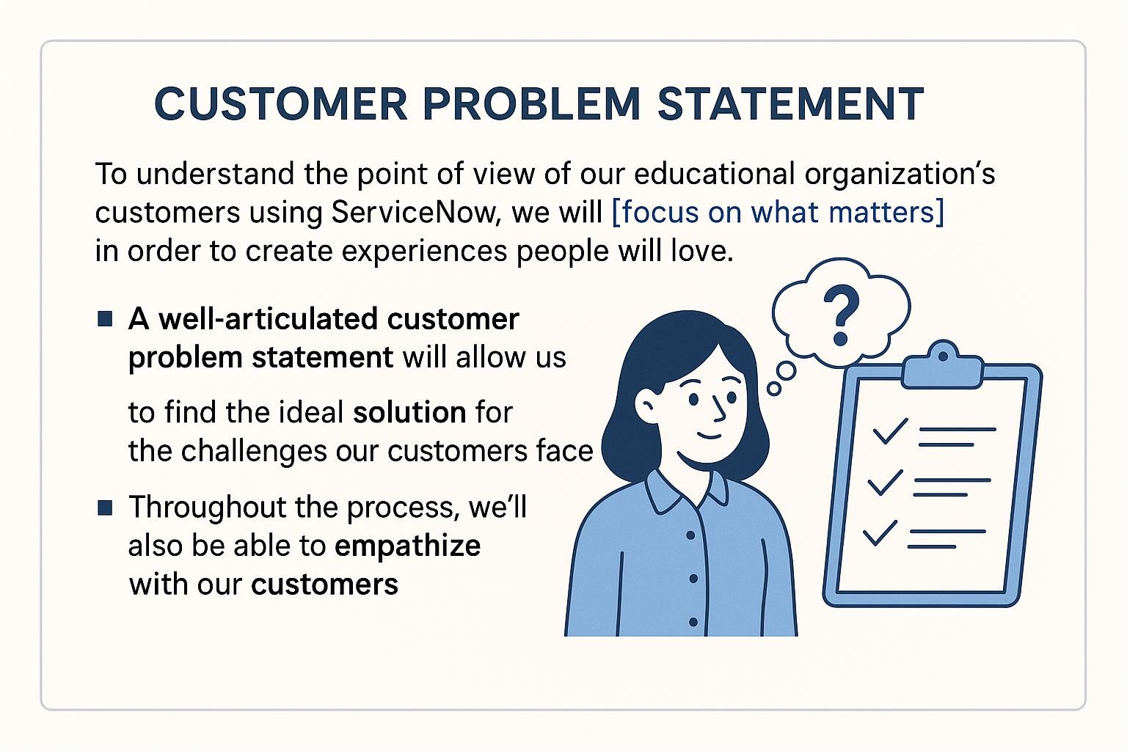

**Example:**

|  |  |  |  |  |  |
| --- | --- | --- | --- | --- | --- |
| **Problem**  **Statement**  **(PS)** | **I am**  **(Customer)** | **I’m trying to** | **But** | **Because** | **Which makes me**  **feel** |
| PS-1 | A teacher | Know maintain students data | It’s time taking and more paperwork | There are a lot of students | stressed |
| PS-2 | A principal of a school | know the number of admission happening | We can’t maintain it with paper work | There are many works going on during admission time | Confused |